WEEK NUMBER: | 5
STUDENT NAME: | Anas Al Azad
STUDENT ID: | [YOUR STUDENT ID]
Week 5 – Python intro, Google Colab, scikit-learn & Linear Regression
My checklist for this week – ticked = done (notebooks and plots are all in the Lab 5 folder of my repo), unticked = still on my to-do list.
LAB 5 CHECKLIST (☒ = done, ☐ = still to do) |  | STATUS
☒ | Read the Week 5 tutorial sheet + the “Google Colab introduction” PDF | Done
☒ | Python basics – ran every example from the sheet + my own variations (python_basics_practice.ipynb) | Done
☒ | Made a Colab walkthrough notebook that follows the Colab PDF step by step (colab_walkthrough.ipynb) | Done
☒ | Went through Linear_Regression.ipynb and matched each step to the theory (load → train → weights → predict → MSE) | Done
☒ | Extra: 3-house example + gradient descent from scratch + learning-rate experiment (linear_regression_extras.ipynb) | Done
☒ | Extra: proper train/test split (diabetes dataset) | Done
☒ | Wrote a setup-check script for my laptop (screenshot_demo_setup_check.py) | Done
☐ | Log into Google Colab and run colab_walkthrough.ipynb on a GPU runtime | To do
☐ | Run Linear_Regression.ipynb myself in Colab | To do
☐ | Install scikit-learn + Jupyter on my laptop and import sklearn in a new notebook | To do
☐ | Run part D of the extras notebook (California Housing train/test split) somewhere with internet | To do
☐ | Add my screenshots (yellow boxes below) | To do
Progress: 7/12 items done

WEEK # | 5
Dates covered: | 10-16 September 2026
Lab tasks | What I did | TIME SPENT | Learning & Problems
Python introduction  Lab sheet section 1 | - Went through every example in the sheet: variables, operators (+ - * / // % **), string concat/repeat, implicit + explicit type conversion, if/else, if/elif/else, functions, while + for loops, range(), import math.  - Put it all in python_basics_practice.ipynb with a “my try” cell after each topic – e.g. looped over all the “try these variations” numbers at once instead of editing them by hand, caught the error from 123 + "456", used f-strings and enumerate().  - Wrote a small predict_price() function (y = m·x + b) so the Python part links to the linear regression part. | 1.5 h | Learning:  - Python is dynamically typed – int→float happens automatically but int + str doesn't, you have to cast.  - / always gives a float, // floors, % is the remainder; range(10) stops at 9.  - Indentation is the block structure.  Problems:  - The sheet's loop examples use sum as a variable name, which hides the built-in sum() (calling it afterwards gives *'int' object is not callable*). Renamed it to total / used del sum.
Google Colab intro  “Google Colab introduction” PDF | - Read the Colab PDF and built colab_walkthrough.ipynb that follows it: code + text cells, runtime type GPU/TPU, tf.test.gpu_device_name(), TPU check, !pip install, !git clone, file hierarchy, files.upload() and drive.mount().  - Added !nvidia-smi and a second TPU check with tf.config.list_logical_devices('TPU').  - Still to do: run it in Colab on a T4 GPU runtime (screenshots 5.1–5.4). | 1 h | Learning:  - Colab = Jupyter in the browser with the ML libraries preinstalled + free (time-limited) GPU/TPU.  - ! runs a shell command from a cell.  - Session storage gets wiped when the runtime resets – mount Google Drive to keep files.  Problems:  - The sheet's TPU check relies on the COLAB_TPU_ADDR variable, which (as far as I can tell) the newer TPU runtimes don't set, so I added the TensorFlow check as a backup.
scikit-learn + Jupyter set-up  Lab sheet section 3 | - Worked out the local set-up from the sheet: pip install scikit-learn, then jupyter notebook, new notebook, import sklearn.  - Wrote screenshot_demo_setup_check.py – prints the Python/numpy/pandas/sklearn/matplotlib/notebook versions and fits a tiny LinearRegression so I can check everything works in one go.  - Still to do: install it on my laptop + screenshot 5.5. | 0.5 h | Learning:  - sklearn = the “classic ML” library (regression, classification, clustering, dimensionality reduction) with the same fit() / predict() interface for everything.  Problems:  - Easy to mix up: the pip package is scikit-learn but you import sklearn (the old pip install sklearn package name is deprecated).
Linear Regression notebook  Linear_Regression.ipynb | - California Housing: 20,640 houses × 8 features, target = median house value (in $100k).  - LinearRegression().fit() → looked at the 8 learned weights (coef_, e.g. MedInc +0.437, AveBedrms +0.645, Latitude/Longitude about −0.42/−0.43) and the intercept (−36.94).  - Predicted house #5: 2.675 vs true 2.697 – pretty close. MSE = 0.524, and the numpy version np.mean((pred - y)**2) gives exactly the same number.  - Matched it to the theory: y = w0 + w1x1 + … + w8x8, cost J(w) = ½Σ(ŷ − y)². | 1 h | Learning:  - Training = finding the weights that minimise the cost function.  - The sign of a weight shows if a feature pushes the price up or down.  - The notebook measures the MSE on the same data it trained on, which is a bit optimistic (so I tried a proper test split in my extras).  Problems:  - The dataset download (fetch_california_housing) got a 403 Forbidden from the figshare link on the cloud machine I first used – the network there blocks it. Works in Colab, so I'm re-running it there.
Extra – my own experiments  linear_regression_extras.ipynb | - Fitted the 3-house example from the sheet: price = 0.1759 × area + 0.76, so a 2500 sq.ft house ≈ $440.6k (Fig 5.1).  - Coded gradient descent from scratch with the sheet's cost function and update rule – got exactly the same m and b as sklearn (final J = 555.3).  - Learning-rate test: α = 0.005 too slow, 0.05 / 0.3 converge, 0.65 oscillates, 0.7 diverges (Fig 5.2).  - Proper 80/20 train/test split on sklearn's diabetes data: train R² 0.528, test R² 0.453, test MSE ≈ 2900 (Fig 5.3). Same idea for California Housing is part D (needs the download). | 2 h | Learning:  - Feature scaling is basically required for gradient descent.  - GD only converges when α is below a limit (here 2/3); sklearn doesn't need α because it solves least squares directly.  - Test error > training error, so always keep a test set.  Problems:  - GD on the raw areas (~1000s) blew up to 1e205 / nan within 20 iterations. Fixed by standardising the feature (z-score) and converting the weights back afterwards.
TOTAL TIME THIS WEEK |  | 6 h | + about 45 min still to do in Colab

Screenshots:
Figures 5.1–5.3 come straight out of my linear_regression_extras.ipynb. The yellow boxes are screenshots I still need to grab from Colab / my laptop.
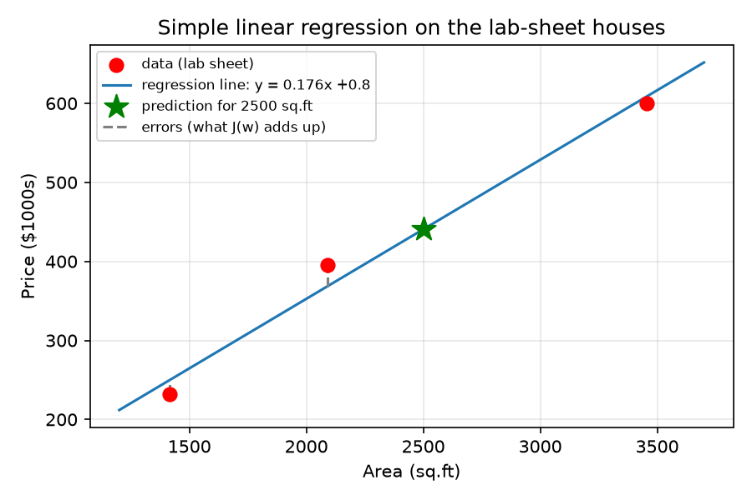
Figure 5.1 – regression line for the 3 houses from the lab sheet (dashed = errors the cost function adds up)
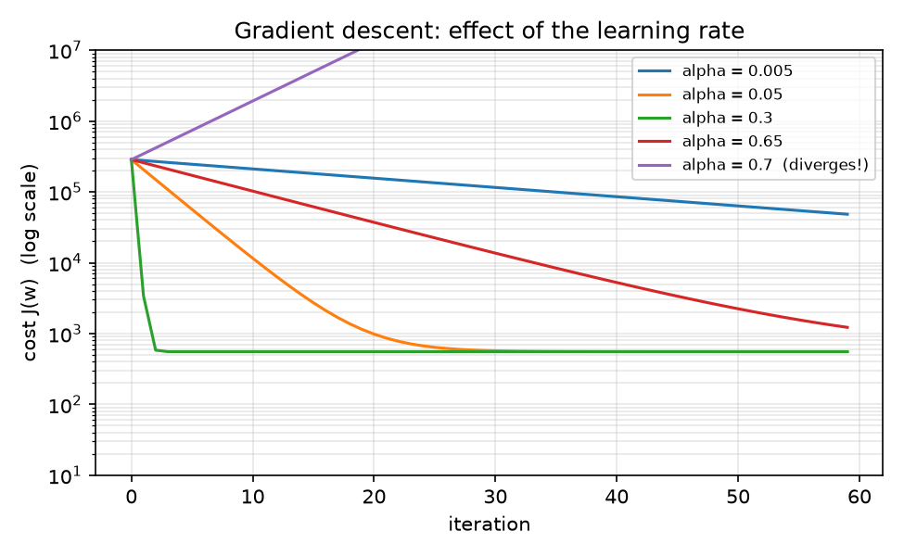
Figure 5.2 – my gradient descent with different learning rates – too small is slow, too big diverges
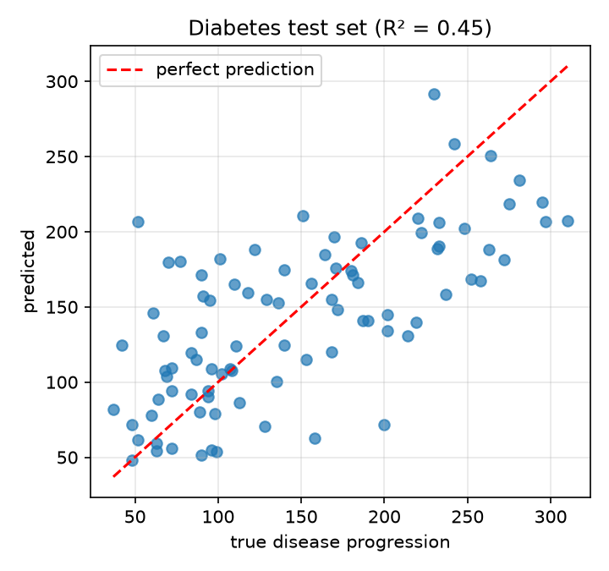
Figure 5.3 – train/test split on the diabetes dataset – predicted vs true on the 20% test set
[SCREENSHOT 5.1] Colab – my walkthrough notebook running
What to capture: the whole browser window with colab_walkthrough.ipynb open in Colab: the first code cell's output (“Hello from Google Colab!”) and the text cell under it, with your Google account icon visible top-right.
Save as Lab 5/screenshots/5.1_colab_first_cells.png then run python _tools/insert_screenshots.py (or just paste the image here and delete this box).
Screenshot 5.1 – Colab – my walkthrough notebook running
[SCREENSHOT 5.2] Colab – changing the runtime type to GPU
What to capture: Runtime → Change runtime type dialog with T4 GPU selected (before you press Save).
Save as Lab 5/screenshots/5.2_colab_runtime_gpu.png then run python _tools/insert_screenshots.py (or just paste the image here and delete this box).
Screenshot 5.2 – Colab – changing the runtime type to GPU
[SCREENSHOT 5.3] Colab – GPU check
What to capture: the tf.test.gpu_device_name() cell showing '/device:GPU:0' and the !nvidia-smi table underneath it.
Save as Lab 5/screenshots/5.3_colab_gpu_check.png then run python _tools/insert_screenshots.py (or just paste the image here and delete this box).
Screenshot 5.3 – Colab – GPU check
[SCREENSHOT 5.4] Colab – pip install, git clone and the Files pane
What to capture: the !pip install pandas and !git clone cells with their output, with the Files pane (folder icon on the left) open showing the Testing-and-Debugging-Tools folder (and drive if you mounted it).
Save as Lab 5/screenshots/5.4_colab_pip_clone_files.png then run python _tools/insert_screenshots.py (or just paste the image here and delete this box).
Screenshot 5.4 – Colab – pip install, git clone and the Files pane
[SCREENSHOT 5.5] My laptop – scikit-learn installed
What to capture: terminal after pip install scikit-learn notebook and then python screenshot_demo_setup_check.py – the whole output down to “All good - ready for the lab!”.
Save as Lab 5/screenshots/5.5_local_sklearn_setup.png then run python _tools/insert_screenshots.py (or just paste the image here and delete this box).
Screenshot 5.5 – My laptop – scikit-learn installed
[SCREENSHOT 5.6] Linear_Regression.ipynb in Colab – training
What to capture: the “3 - Train a model” section: the lin_reg.fit(...) cell, the coef_ array and the intercept (−36.94…).
Save as Lab 5/screenshots/5.6_linreg_train.png then run python _tools/insert_screenshots.py (or just paste the image here and delete this box).
Screenshot 5.6 – Linear_Regression.ipynb in Colab – training
[SCREENSHOT 5.7] Linear_Regression.ipynb in Colab – testing
What to capture: the “4 - Test a model” section: predict for sample 5 (2.675), the true value (2.697) and both MSE cells (0.5243…).
Save as Lab 5/screenshots/5.7_linreg_test_mse.png then run python _tools/insert_screenshots.py (or just paste the image here and delete this box).
Screenshot 5.7 – Linear_Regression.ipynb in Colab – testing

